COAL LAB 08
22F - 3441
BSCS - 3D
CODE 1:
org 0x100
jmp start
fibonacci:
push bp
mov bp,sp
sub sp,2
push ax
push bx
push cx
push si
mov dx,[bp+4]
cmp dx,0
je zero
cmp dx,1
je zero
mov cx,ax
mov ax,0
mov bx,1
mov dx,0
l1:
mov dx,bx
add dx,ax
mov ax,bx
mov bx,dx
dec cx
cmp cx,0
jne l1
zero:
mov[bp-2],dx
mov ax,[bp-2]
pop si
pop cx
pop bx
pop ax
mov sp,bp
pop bp
ret
start:
mov ax,5
push ax
call fibonacci
mov ax,0x4c00
int 0x21
OUTPUT:
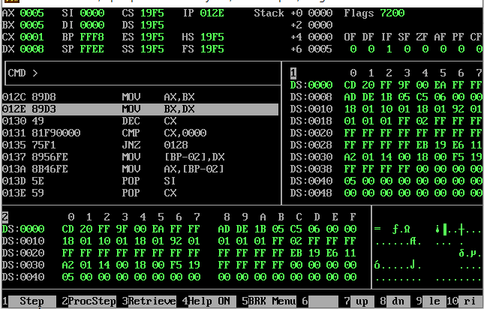
CODE 2:
org 0x100
jmp start
switchstack:
mov[bp-2],dx
push bp
mov bp,sp
sub sp,2
pop bp
ret
start:
mov ax,5
push ax
call switchstack
call switchstack
mov ax,0x4c00
int 0x21

OUTPUT:
